**Personal Information**:

Last name: _______________________ First Name: ____________________ Birth date: ____________

Address _______________________________________ City/State ______________ Zip ______________

Email address: __________________________________ Contact phone ___________________________

**Education**:

High School: _______________________ City ____________________ Graduation Year _____ GPA _____

College You Plan To Attend_____________________________ Major ______________________________

Extracurricular Activities/Public Service (back page if necessary)____________________________________

________________________________________________________________________________________

**Materials required**:

1. Attach one photo of yourself taken in the town of Locke during 2022.

2. Essay (500 words): What is historically significant about the town of Locke?

3. Transcript of high school. Transcript must be sealed to be considered official.

4. One letter of recommendation from your current high school teacher or counselor.

If your application is not filled in completely or you do not provide all the required items, your application may be disqualified. All decisions of the Scholarship Committee are final.

For all applicants:

I certify the information that I have supplied is complete, correct, and give permission to Locke Foundation to verify. If selected for scholarship award, I understand I must attend the Locke Asian Pacific Street Festival on Saturday, May 7, 2022. Festival attendance subject to Public Safety Regulations.

Applicant signature ________________________ Date ________________________________

Locke Foundation

*A non-profit organization benefiting Locke,*

*the last rural Chinese town in the United States*

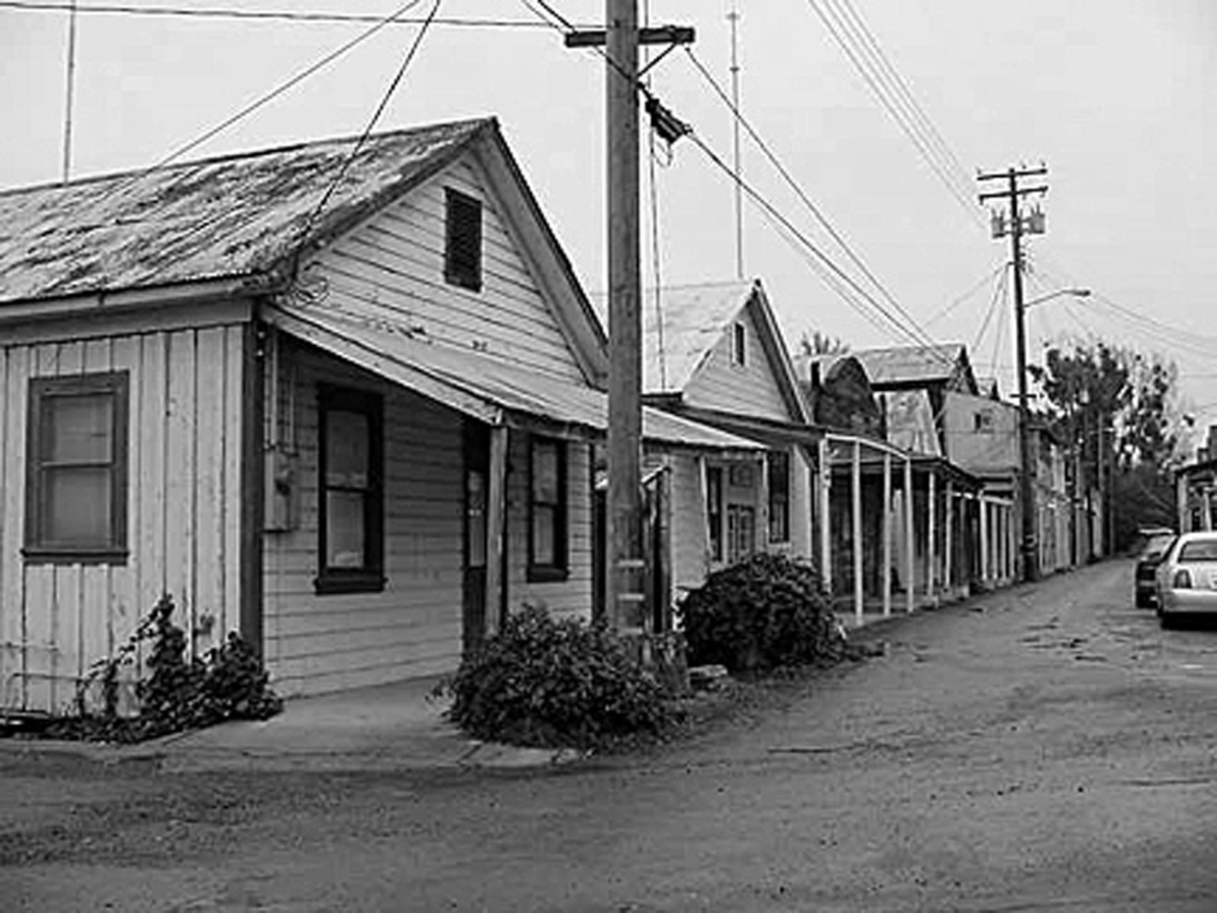

2022 Locke Foundation Scholarship Form

Application Deadline: 5 pm, April 8, 2022. Mail application with supporting materials to Locke Foundation,

P. O. Box 1085, Walnut Grove, CA 95690, or email with attachments to lockefoundation@frontiernet.net